Monthly Operations Review: Performance of 3 store branches
(i) Prepare your response:
Organize your thoughts clearly using a professional document editor. It is completed and it is as follows.
- Profitability:
Net Profit is calculated as Total Sales minus Operating Cost, and Profit Margin reflects how much of every dollar in revenue the branch actually keeps. Calculation and corresponding Chart (visuals) are clearly shown in the enclosed excel file.

Formula:
Net Profit=Total Sales −Op. Cost
Profit Margin (%)=(Net Profit / Total Sales) ×100
Data:

Branch | Total Sales | Op. Cost | Net Profit | Profit Margin %
Branch A | $45,000 | $32,000 | $13,000 | 28.89
Branch B | $38,500 | $21,000 | $17,500 | 45.45
Branch C | $52,000 | $48,000 | $4,000 | 7.69
- Visualization:

Chart1: Net Profit ($) vs Branch.
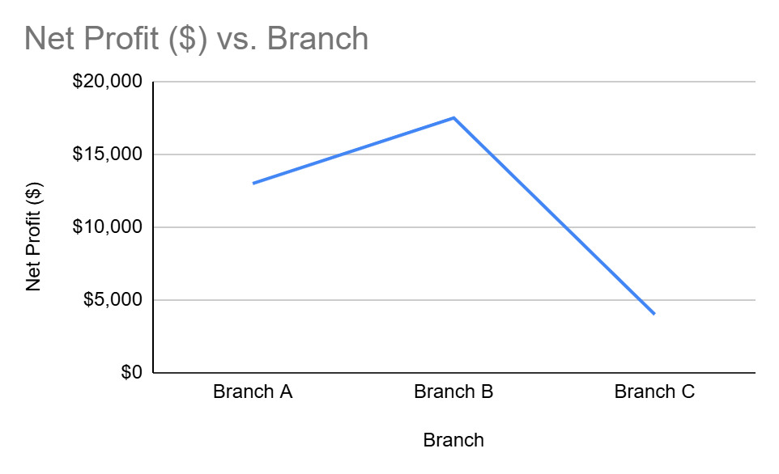Go to next page >>

Chart2: Profit Margin ($) vs Branch

.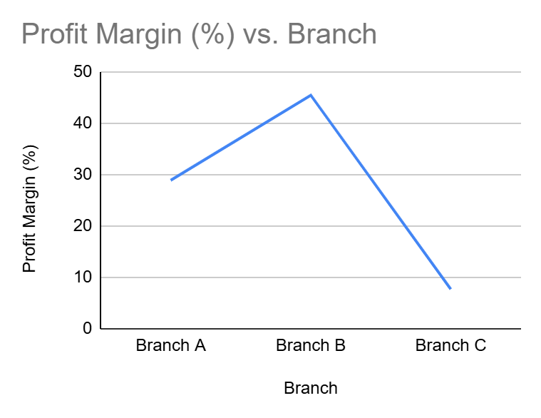

- Sentiment Analysis:
Ranking the branches from best to worst customer experience:
Rank 1 (Best): Branch B — Customers say “Always has stock, friendly staff.” The feedback is fully positive, with no complaints at all.
Rank 2: Branch A — Feedback notes “Great service, but long queues.” People appreciate the service quality, though the wait times cause some frustration.
Rank 3 (Worst): Branch C — Comments include “Expensive shipping, slow delivery.” Both points are negative, showing clear issues with cost and delivery speed.

The "Manager" Pitch:

Branch B stands out as the clear candidate for a performance bonus. It not only delivers the highest net profit of $17,500 but also maintains the strongest margin at 45.45%. On top of that, customer feedback is consistently positive, highlighting reliable stock and friendly staff. This combination of financial strength and customer satisfaction is rare and deserves recognition.

Branch C, while generating the most revenue, is struggling with efficiency. Its operating costs are disproportionately high, leaving only $4,000 in net profit, and customers are dissatisfied with shipping expenses and delivery speed. These issues point to structural problems that need a focused process improvement plan.

Branch A is in solid shape both financially and reputationally. Customers appreciate the service, though queue times remain a pain point. Addressing that single issue could elevate Branch A’s performance further without requiring a major overhaul.

Bonus Challenge:

Branch C with 15% lower Operating Costs:

Step 1: Start with current Branch C numbers
- Total Sales = $52,000
- Operating Costs = $48,000 Go to next page >>

Step 2: Calculate the cost reduction amount
15% of $48,000 = 0.15 × 48,000 = $7,200

Step 3: Compute new Operating Costs
New Op. Cost = 48,000 − 7,200 = $40,800

Step 4: Compute new Net Profit
New Net Profit = Sales − New Op. Cost = 52,000 − 40,800 = $11,200

Step 5: Compute new Profit Margin %
New Profit Margin % = (New Net Profit / Sales) × 100
= (11,200 / 52,000) × 100 = 21.538...% ≈ **21.54%**

Bonus challenge answer: Branch C, after 15% Op. Cost reduction is as follows.
- New Net Profit: $11,200
- New Profit Margin: 21.54% <<Move to next page>>
(ii) Explain Your Process:
- Provide the "how" and "why" behind your work through a written breakdown of your logic or a short video walkthrough.

Scenario given:
Comparing branch performance using Net Profit ($) and Profit Margin (%) to identify financial strength and operational efficiency side‑by‑side.

How:
- Collected Data – Total Sales and Operating Costs for Branches A, B, C.
- Calculated Net Profit – Net Profit = Total Sales − Operating Cost.
  - Example: Branch B → 38,500 − 21,000 = 17,500.
- Calculated Profit Margin – (Net Profit ÷ Total Sales) × 100.
  - Example: Branch B → (17,500 ÷ 38,500) × 100 = 45.45%.
- Visualized Results – 2 Charts:
  - Chart1: Net Profit ($) vs Branch
  - Chart2: Profit Margin (%) vs Branch
- Scenario Testing – Reduced Branch C’s operating cost by 15% → recalculated margin improved to 21.54%.

Why:
- Clarity – Shows both absolute profit and efficiency.
- Decision Support – Highlights Branch B as strongest performer (high profit + high margin).
- Process Insight – Reveals Branch C’s inefficiency despite highest sales.
- Actionable – Demonstrates how cost reduction can materially improve margins.
- Professional Presentation – Concise formulas + Charts make results easy to grasp for non‑technical reviewers.
<<End of document>>

